Working Weight
# Source: AI Source: Provided by: [Data Path: Persons Table -> ID Column: 1, Name_En Column: Motasem Essam] -> From: [ChatGPT] on [7/17/2026]
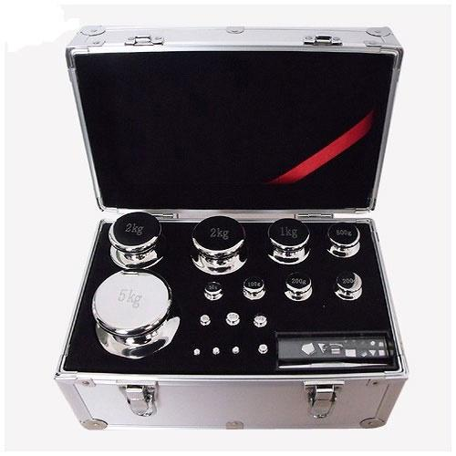
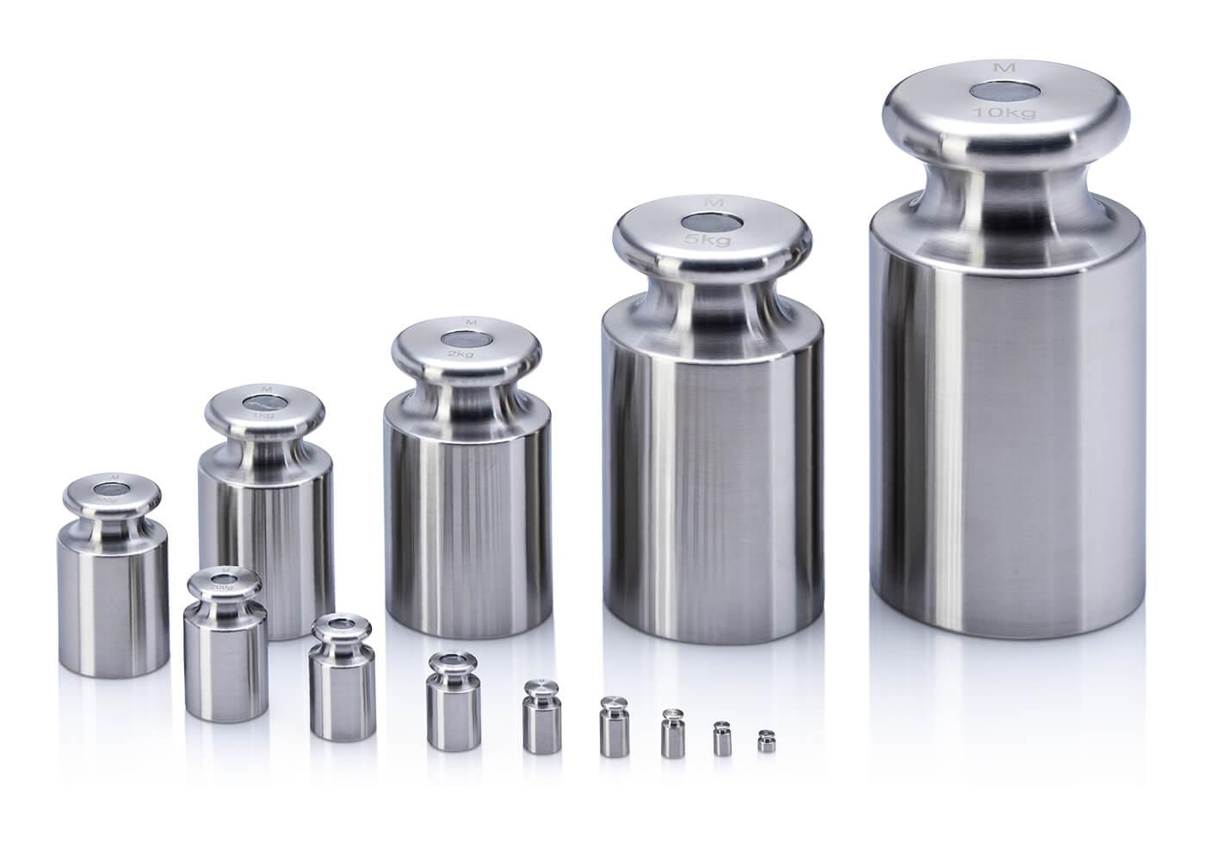
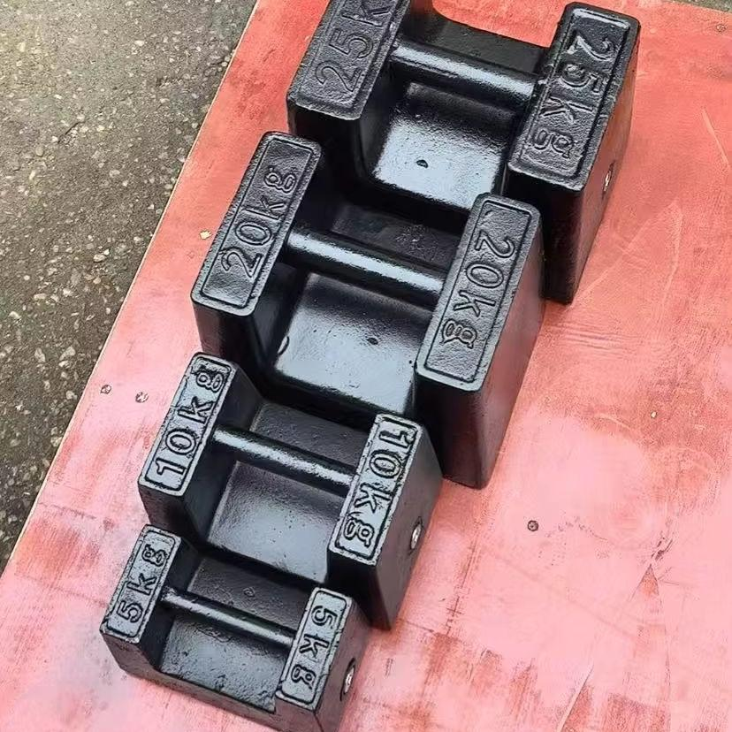
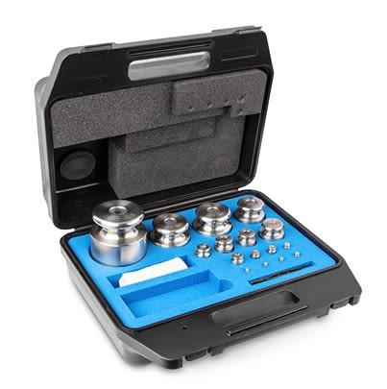
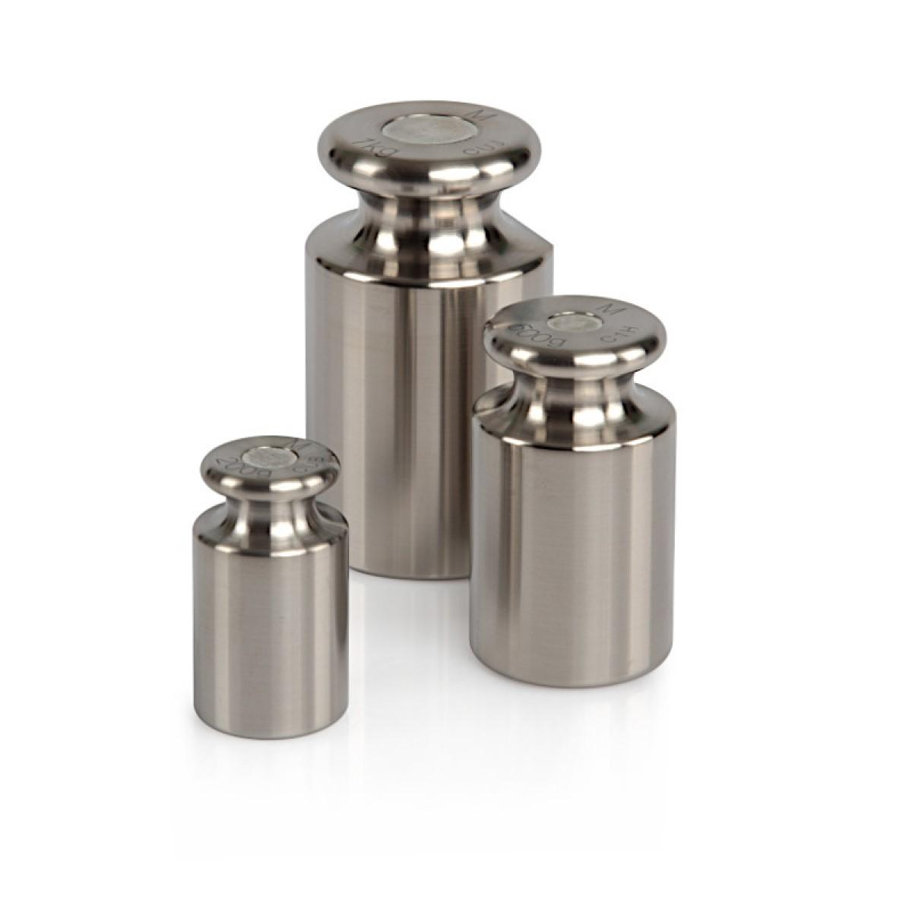
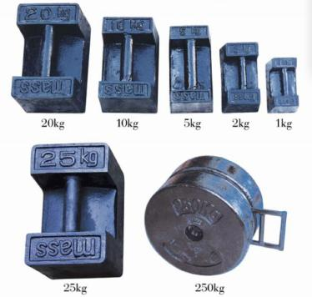
A Working Weight is a reference weight used for routine calibration, verification, and performance checks of weighing instruments during daily or periodic operations. Unlike primary reference standards, working weights are intended for regular laboratory and industrial use and are calibrated against higher-accuracy reference weights.
Working weights are widely used in quality control laboratories, manufacturing plants, pharmaceutical industries, food processing, educational laboratories, and calibration facilities.

Definition
# Source: AI Source: Provided by: [Data Path: Persons Table -> ID Column: 1, Name_En Column: Motasem Essam] -> From: [ChatGPT] on [7/17/2026]
A Working Weight is a calibrated reference mass used for the routine verification and calibration of balances and weighing instruments.

Purpose
# Source: AI Source: Provided by: [Data Path: Persons Table -> ID Column: 1, Name_En Column: Motasem Essam] -> From: [ChatGPT] on [7/17/2026]
Working weights are used to:
- Perform routine balance verification.
- Check weighing accuracy before use.
- Calibrate laboratory balances.
- Verify industrial weighing systems.
- Support quality assurance programs.
- Maintain measurement traceability.

Principle of Operation
# Source: AI Source: Provided by: [Data Path: Persons Table -> ID Column: 1, Name_En Column: Motasem Essam] -> From: [ChatGPT] on [7/17/2026]
A working weight provides a known reference mass.
The measured value displayed by the balance is compared with the certified value of the working weight.
If the difference exceeds allowable tolerance, the instrument requires adjustment or recalibration.

Main Components
# Source: AI Source: Provided by: [Data Path: Persons Table -> ID Column: 1, Name_En Column: Motasem Essam] -> From: [ChatGPT] on [7/17/2026]
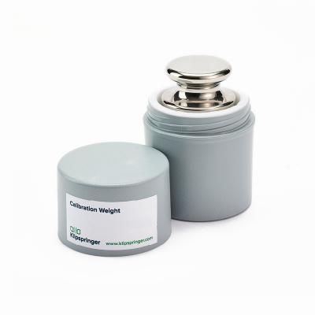
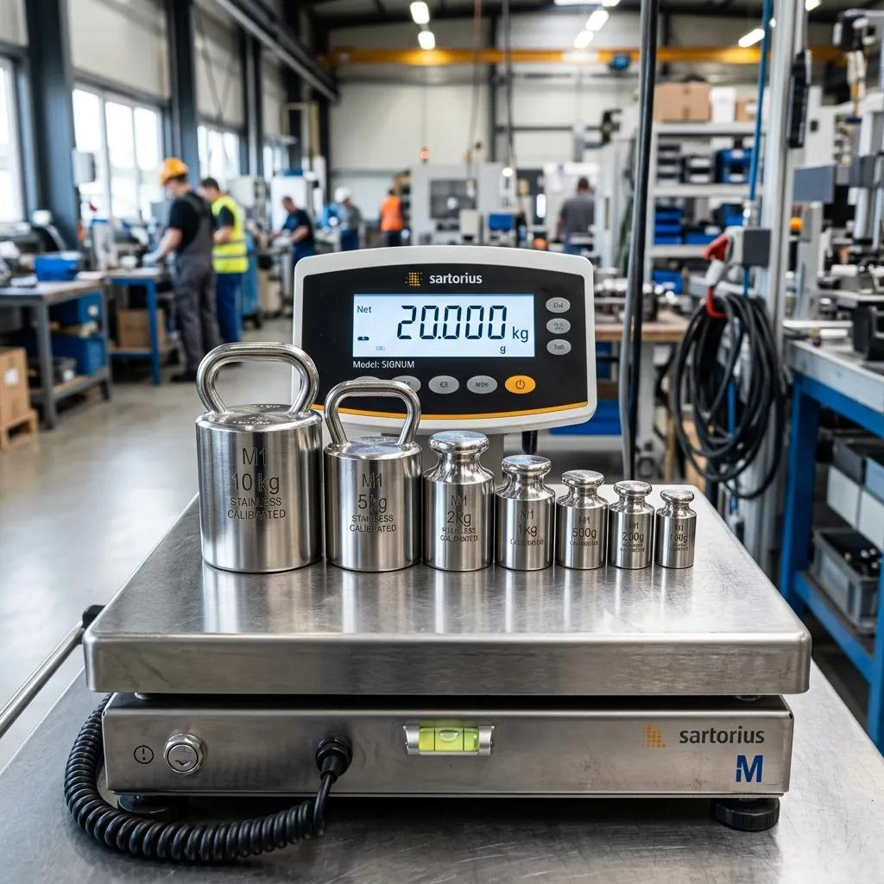
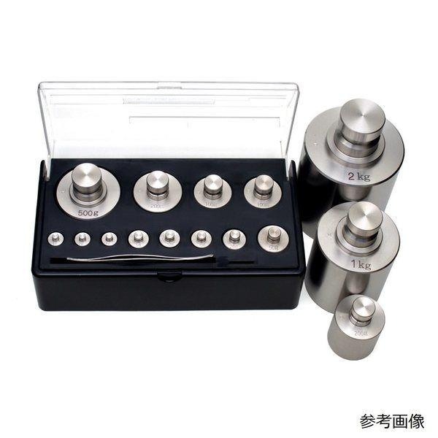
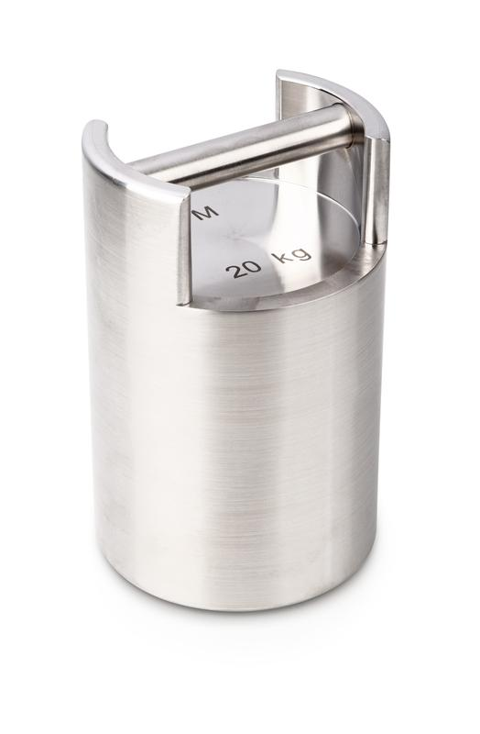
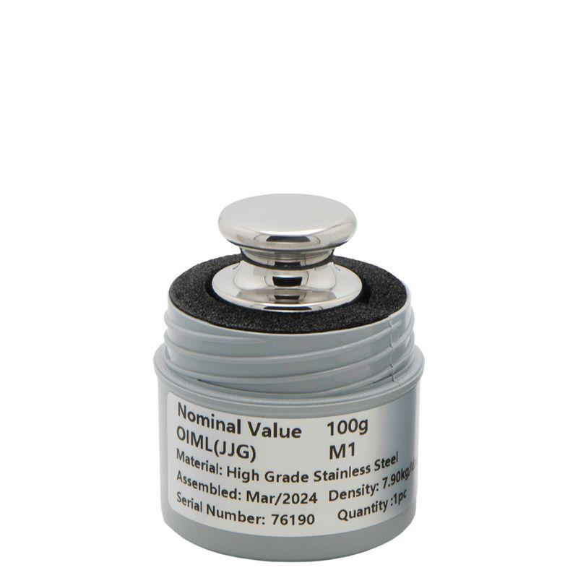
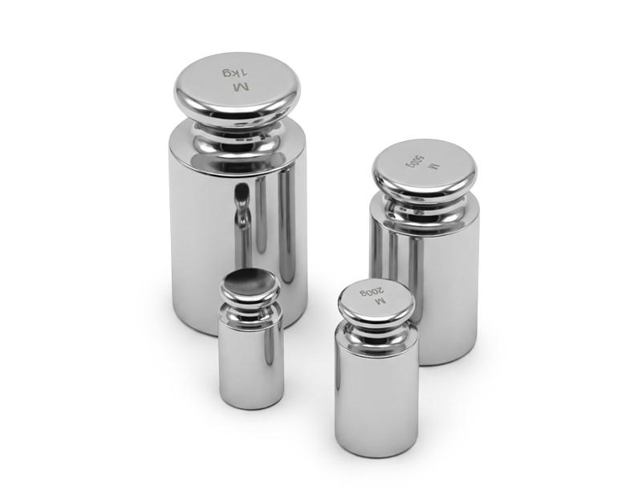
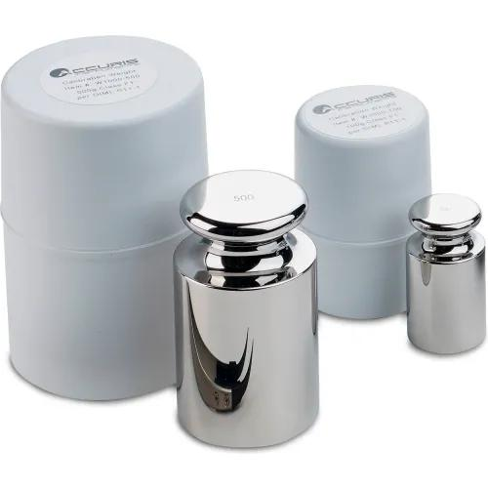
A working weight typically consists of:
- Precision metal body
- Identification marking
- Smooth corrosion-resistant surface
- Protective storage case
- Calibration certificate (when certified)

Types of Working Weights

1. Stainless Steel Working Weights
# Source: AI Source: Provided by: [Data Path: Persons Table -> ID Column: 1, Name_En Column: Motasem Essam] -> From: [ChatGPT] on [7/17/2026]
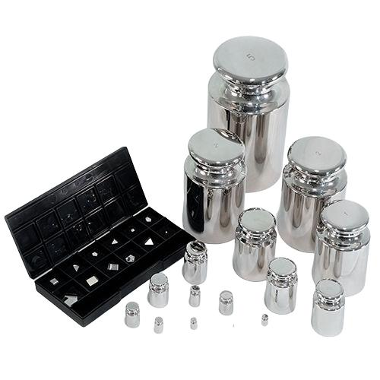
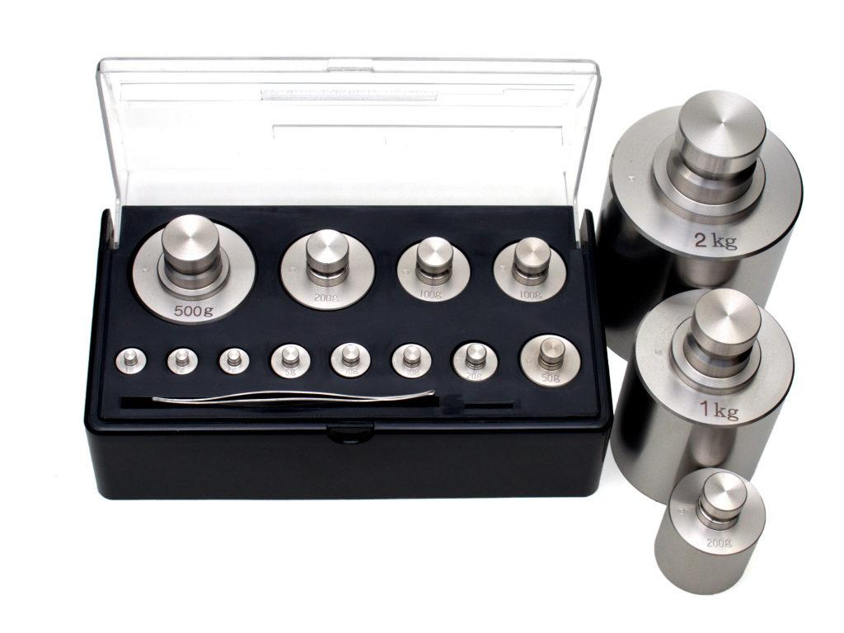
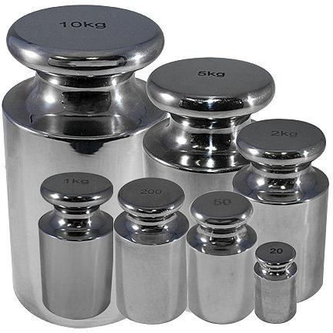
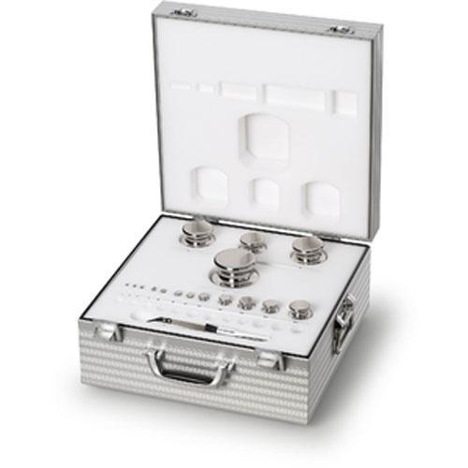
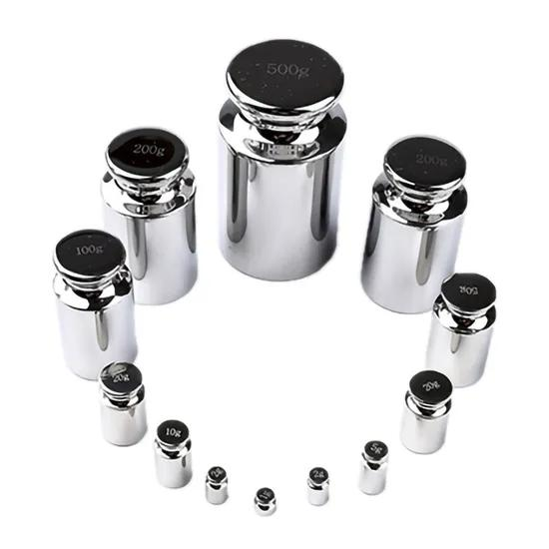
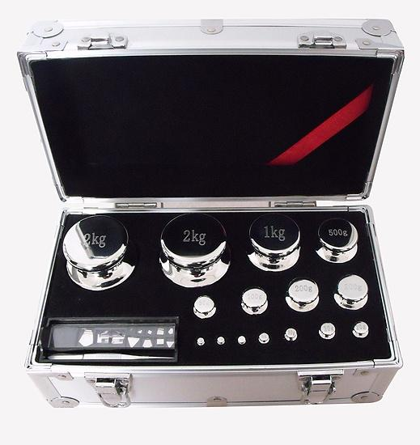
Description
High-quality corrosion-resistant weights used for laboratory and industrial calibration.
Applications
- Laboratories
- Pharmaceutical industries
- Food processing
- Precision weighing

2. Cast Iron Working Weights
# Source: AI Source: Provided by: [Data Path: Persons Table -> ID Column: 1, Name_En Column: Motasem Essam] -> From: [ChatGPT] on [7/17/2026]
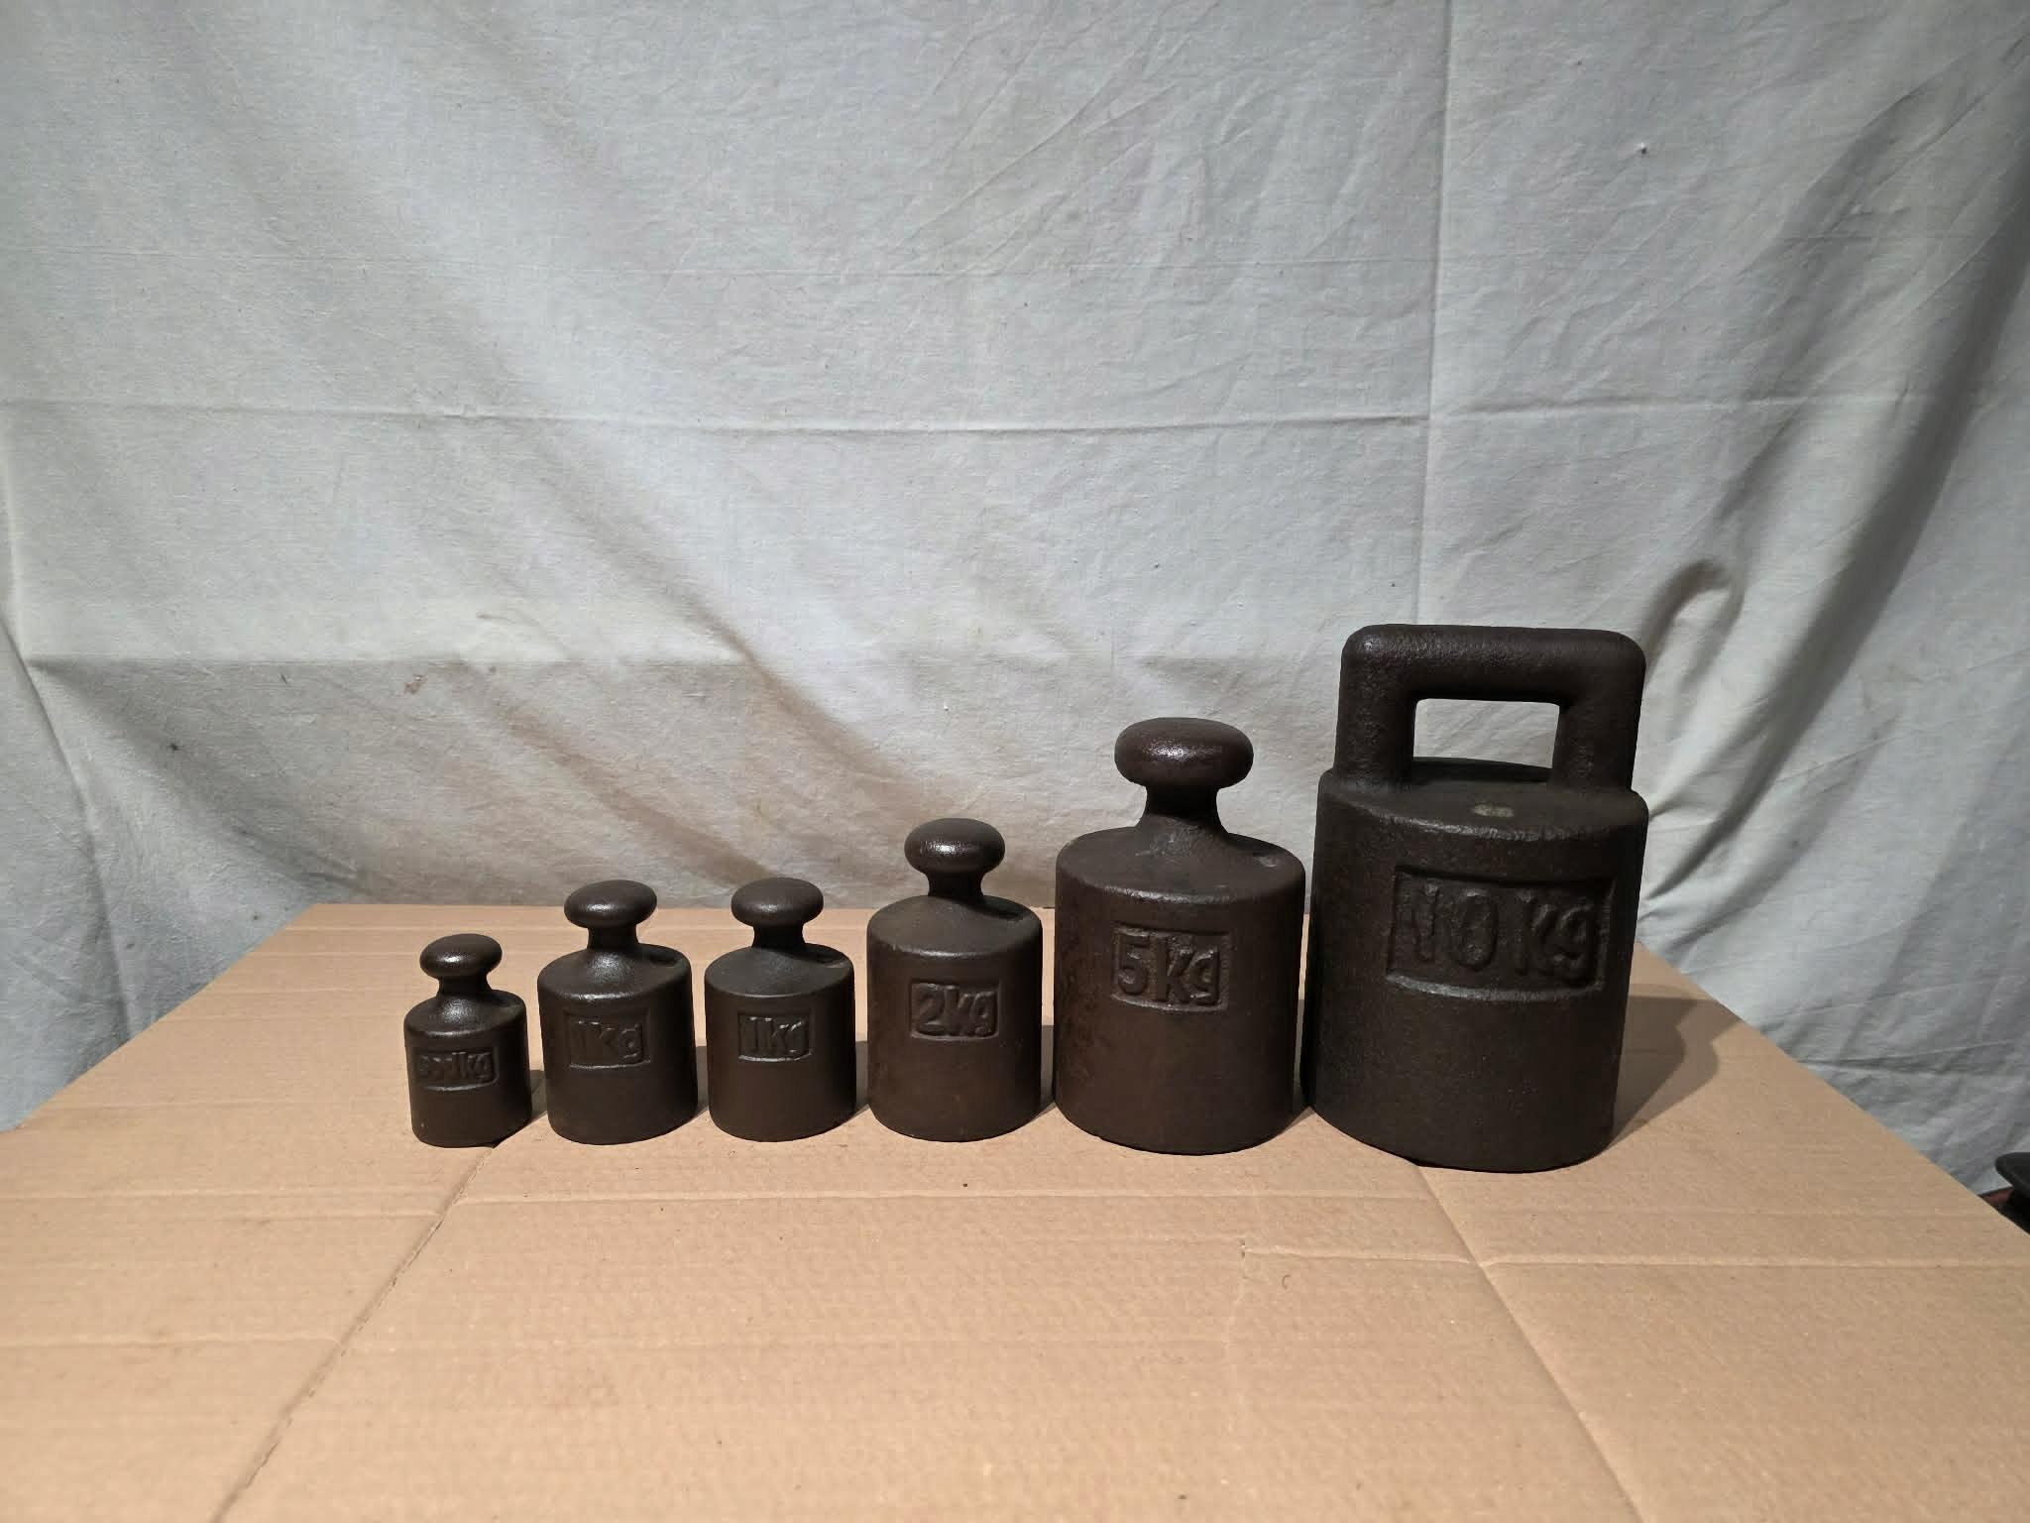
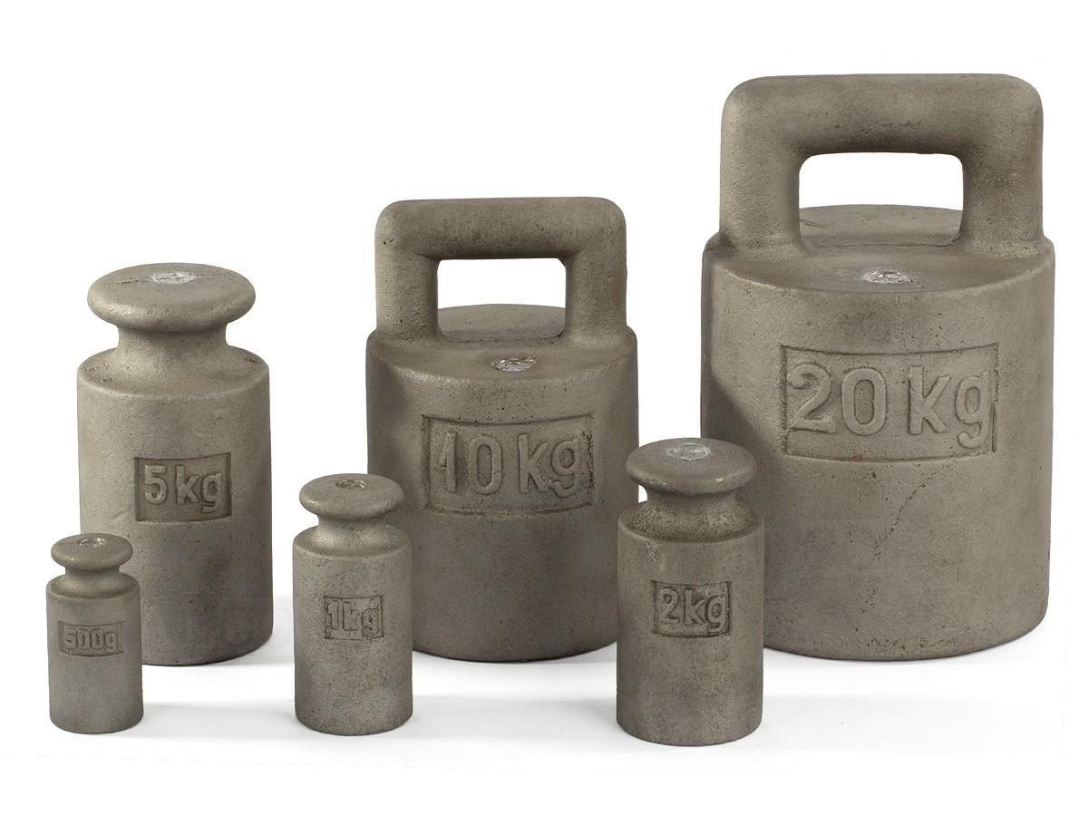
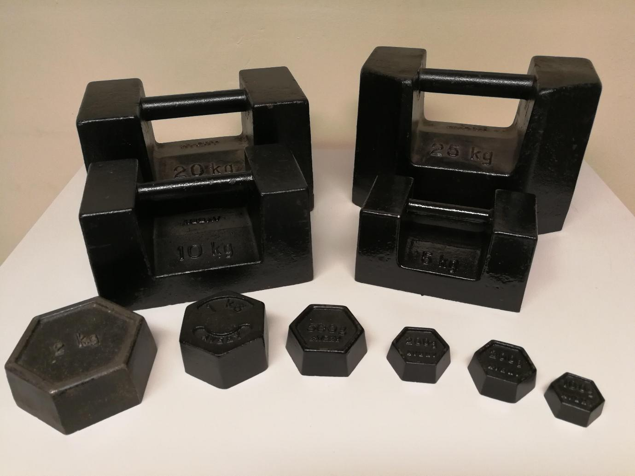
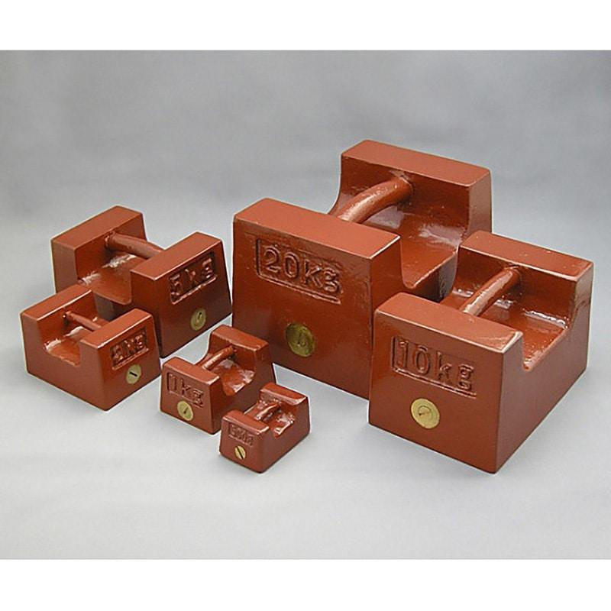

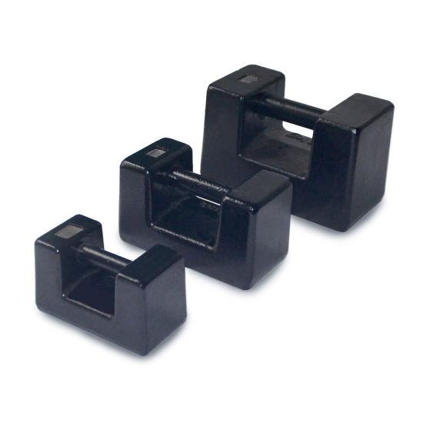
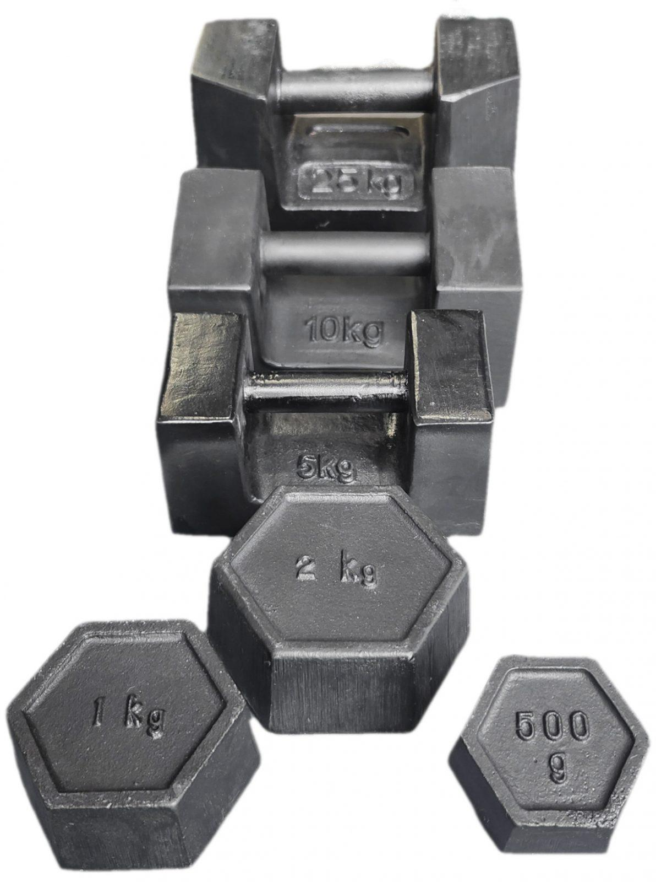
Description
Heavy-duty weights used for large commercial and industrial scales.
Applications
- Platform scales
- Truck scales
- Industrial weighing

3. Knob Working Weights
# Source: AI Source: Provided by: [Data Path: Persons Table -> ID Column: 1, Name_En Column: Motasem Essam] -> From: [ChatGPT] on [7/17/2026]
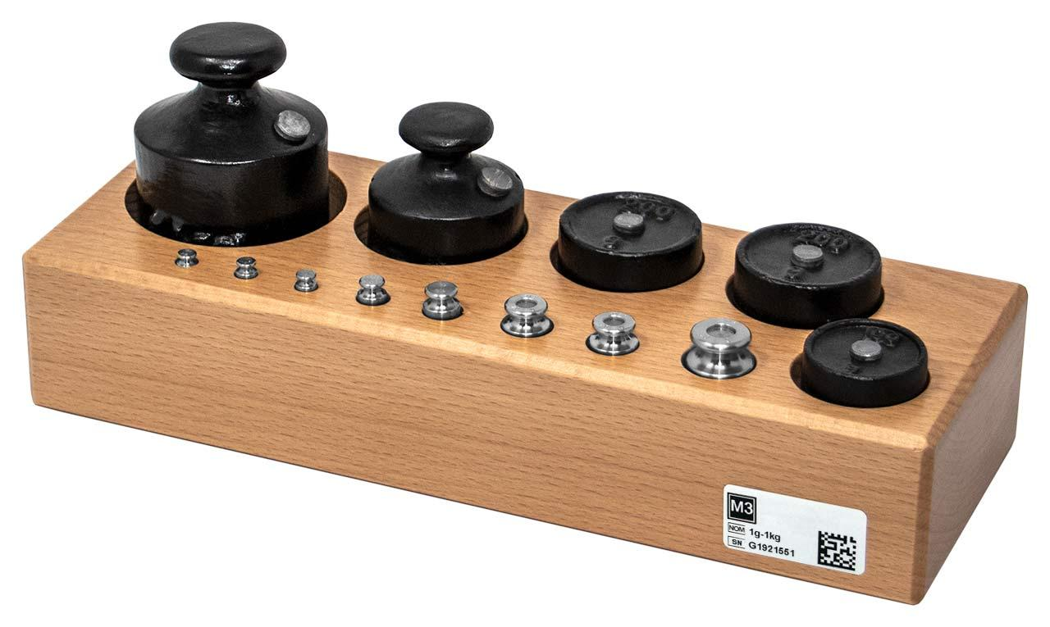
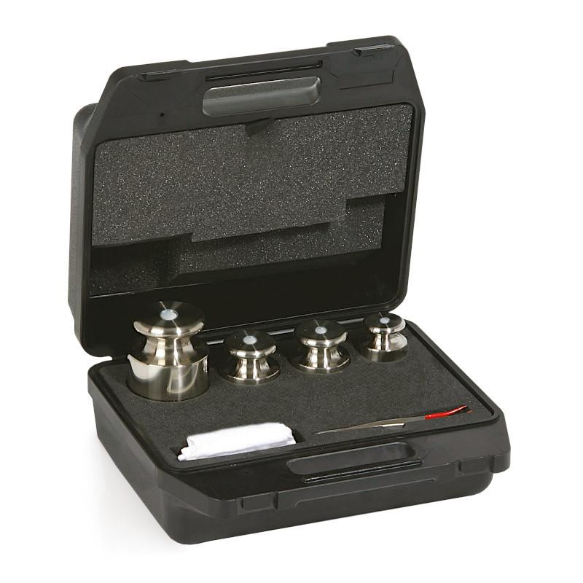
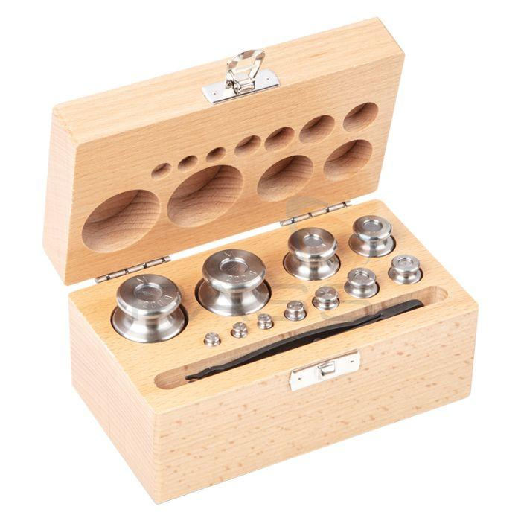
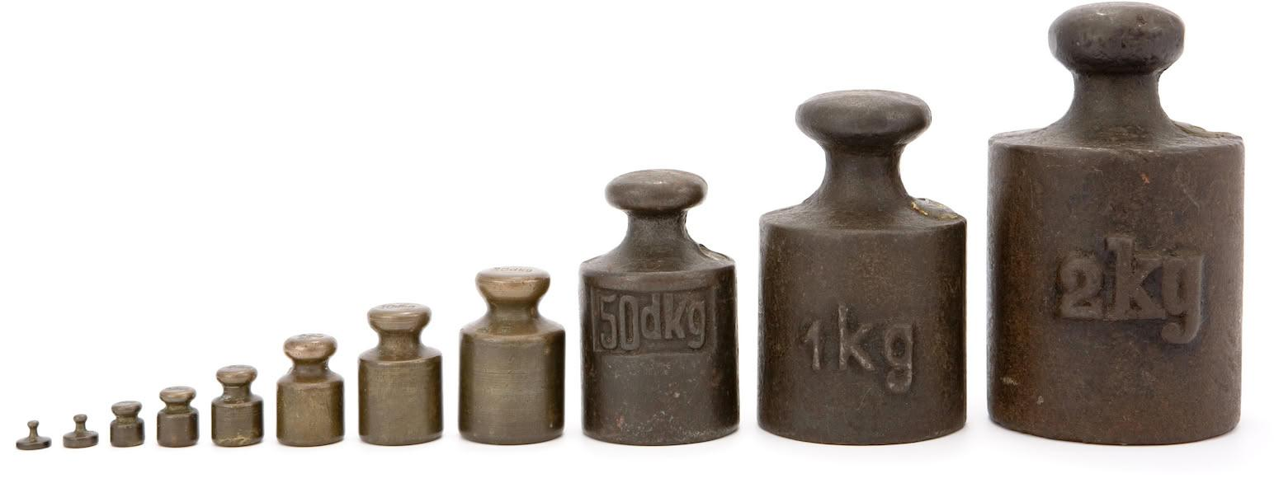
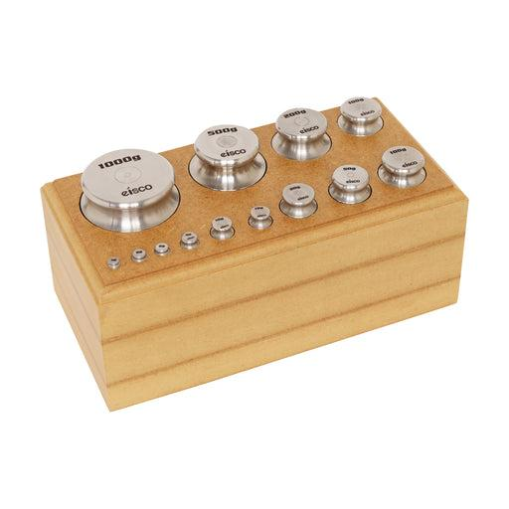
Description
Cylindrical weights with a lifting knob for easy handling.
Applications
- Bench balances
- Platform balances
- General laboratory use

4. Weight Sets
# Source: AI Source: Provided by: [Data Path: Persons Table -> ID Column: 1, Name_En Column: Motasem Essam] -> From: [ChatGPT] on [7/17/2026]
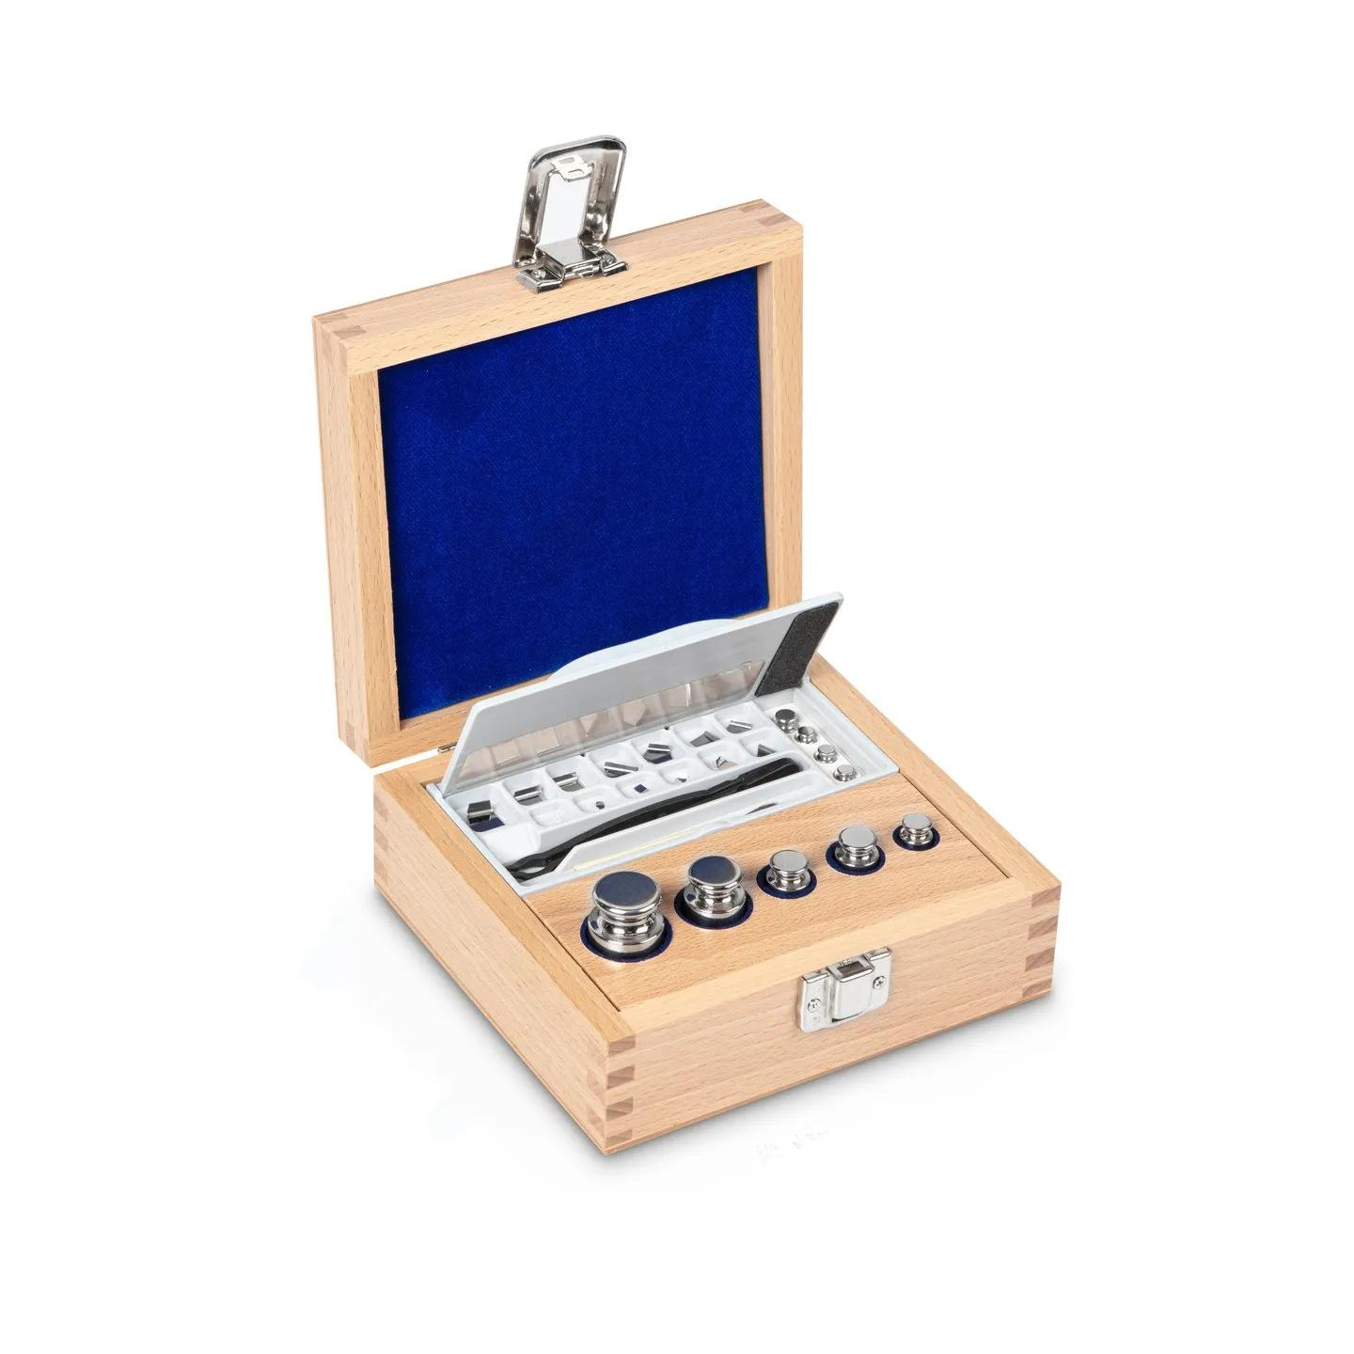
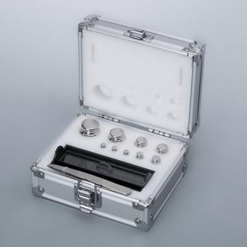
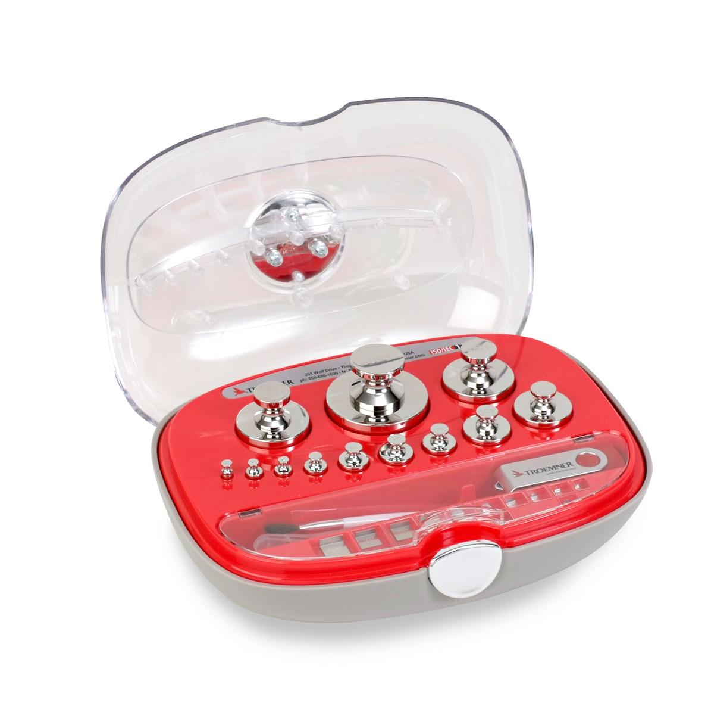

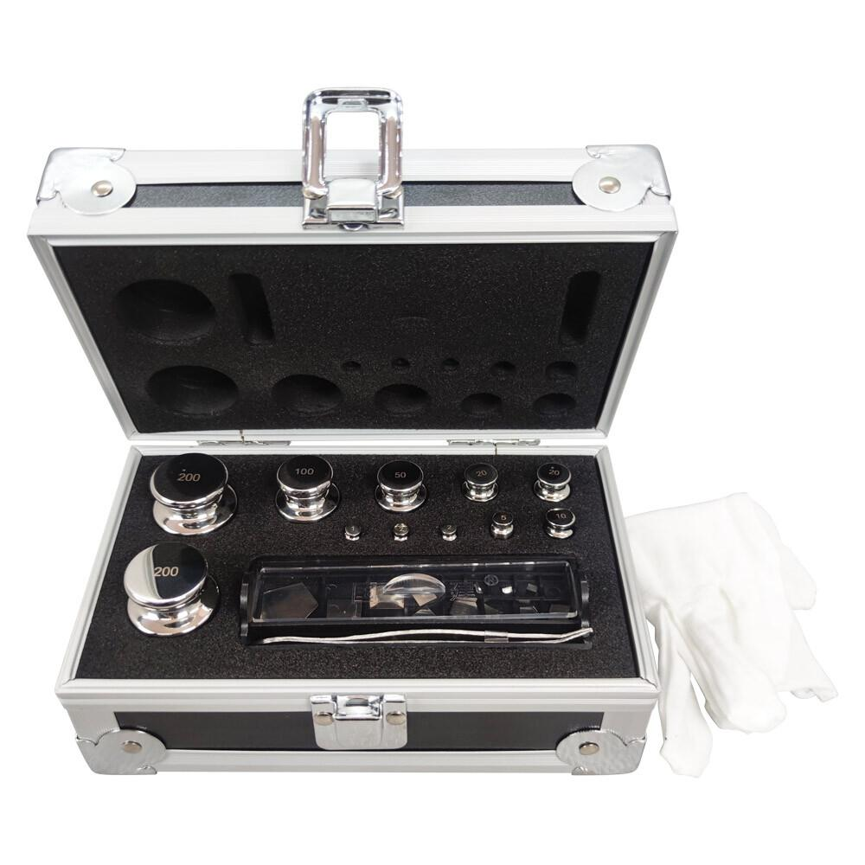
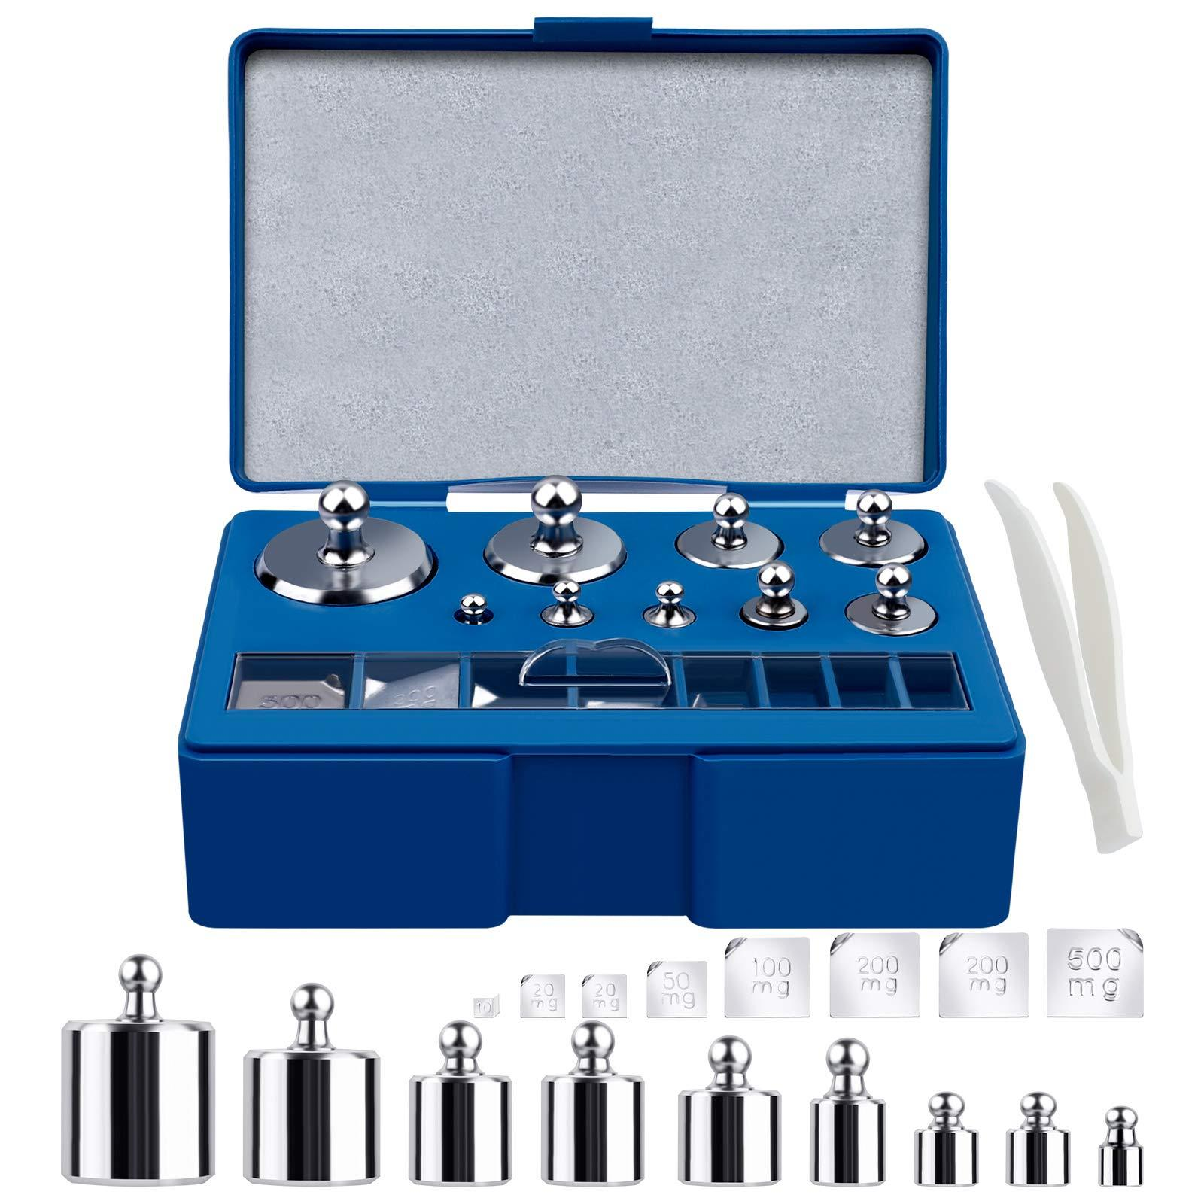
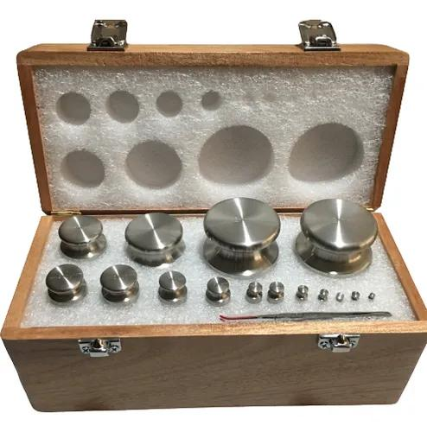
Description
A Weight Set is a collection of precision calibration weights stored in a protective case. The set contains multiple standardized masses, allowing technicians to calibrate and verify balances over a wide range of values. Weight sets are commonly manufactured according to OIML accuracy classes (E1, E2, F1, F2, M1).
Features
- Includes multiple standardized masses (e.g., 1 mg to 1 kg)
- Supplied in a protective wooden, aluminum, or plastic case
- Made from stainless steel or other corrosion-resistant materials
- Individual slots for each weight to prevent damage
- Often includes forceps and gloves for handling small weights
- Supplied with a calibration certificate (certified sets)
Applications
- Calibration laboratories
- Analytical chemistry laboratories
- Pharmaceutical laboratories
- Quality control departments
- Educational laboratories
- Industrial balance verification
- Routine balance calibration and performance testing

OIML Accuracy Classes
# Source: AI Source: Provided by: [Data Path: Persons Table -> ID Column: 1, Name_En Column: Motasem Essam] -> From: [ChatGPT] on [7/17/2026]
Working weights commonly belong to:
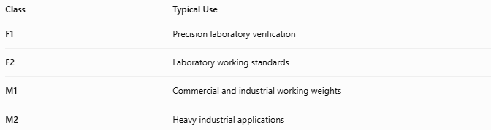
Class | Typical Use
F1 | Precision laboratory verification
F2 | Laboratory working standards
M1 | Commercial and industrial working weights
M2 | Heavy industrial applications

Materials
# Source: AI Source: Provided by: [Data Path: Persons Table -> ID Column: 1, Name_En Column: Motasem Essam] -> From: [ChatGPT] on [7/17/2026]
Common materials include:
- Stainless steel
- Cast iron
- Nickel-plated steel
- Brass (small weights)

Measuring Units
# Source: AI Source: Provided by: [Data Path: Persons Table -> ID Column: 1, Name_En Column: Motasem Essam] -> From: [ChatGPT] on [7/17/2026]
Working weights are manufactured in:
- Milligram (mg)
- Gram (g)
- Kilogram (kg)
- Ton (t)

Measuring Range
# Source: AI Source: Provided by: [Data Path: Persons Table -> ID Column: 1, Name_En Column: Motasem Essam] -> From: [ChatGPT] on [7/17/2026]
Working weights are available in standardized nominal masses suitable for routine calibration tasks.
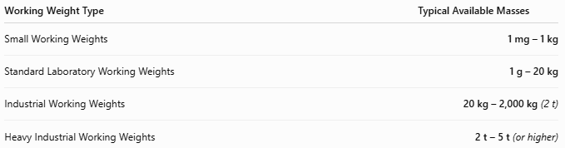
Working Weight Type | Typical Available Masses
Small Working Weights | 1 mg – 1 kg
Standard Laboratory Working Weights | 1 g – 20 kg
Industrial Working Weights | 20 kg – 2,000 kg (2 t)
Heavy Industrial Working Weights | 2 t – 5 t (or higher)

Resolution
# Source: AI Source: Provided by: [Data Path: Persons Table -> ID Column: 1, Name_En Column: Motasem Essam] -> From: [ChatGPT] on [7/17/2026]
Working weights do not measure, so they do not have a measurement resolution.
Instead, they are manufactured in standard nominal mass increments.
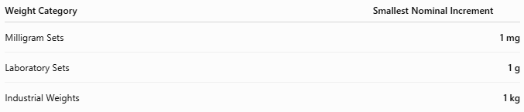
Weight Category | Smallest Nominal Increment
Milligram Sets | 1 mg
Laboratory Sets | 1 g
Industrial Weights | 1 kg

Accuracy
# Source: AI Source: Provided by: [Data Path: Persons Table -> ID Column: 1, Name_En Column: Motasem Essam] -> From: [ChatGPT] on [7/17/2026]
Accuracy depends on the OIML class and determines the maximum permissible error.
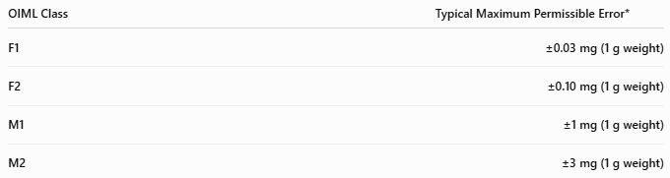
OIML Class | Typical Maximum Permissible Error*
F1 | ±0.03 mg (1 g weight)
F2 | ±0.10 mg (1 g weight)
M1 | ±1 mg (1 g weight)
M2 | ±3 mg (1 g weight)
*Maximum permissible error depends on the nominal mass according to OIML R111.
Notes
- Working weights are not primary standards; they are calibrated against higher-class reference weights.
- F1 and F2 weights are commonly used in laboratories.
- M1 and M2 weights are suitable for commercial and industrial verification.
- Routine recalibration is necessary to maintain traceability and accuracy.

How to Use Working Weights
# Source: AI Source: Provided by: [Data Path: Persons Table -> ID Column: 1, Name_En Column: Motasem Essam] -> From: [ChatGPT] on [7/17/2026]
- Ensure the balance is clean and level.
- Zero (tare) the balance.
- Place the working weight carefully on the weighing pan.
- Compare the displayed value with the certified mass.
- Record the result and recalibrate the balance if required.

Applications
# Source: AI Source: Provided by: [Data Path: Persons Table -> ID Column: 1, Name_En Column: Motasem Essam] -> From: [ChatGPT] on [7/17/2026]
Working weights are used in:
- Laboratories
- Manufacturing
- Food industry
- Pharmaceutical industry
- Calibration laboratories
- Educational institutions
- Industrial quality control

Advantages
# Source: AI Source: Provided by: [Data Path: Persons Table -> ID Column: 1, Name_En Column: Motasem Essam] -> From: [ChatGPT] on [7/17/2026]
Working weights:
- Support routine calibration.
- Are durable and reusable.
- Maintain weighing accuracy.
- Provide traceability when properly calibrated.
- Are available in many sizes and accuracy classes.

Limitations
# Source: AI Source: Provided by: [Data Path: Persons Table -> ID Column: 1, Name_En Column: Motasem Essam] -> From: [ChatGPT] on [7/17/2026]
Working weights:
- Require periodic recalibration.
- Can become contaminated or damaged.
- Are less accurate than primary reference standards.
- Must be handled correctly to preserve accuracy.

Sources of Error
# Source: AI Source: Provided by: [Data Path: Persons Table -> ID Column: 1, Name_En Column: Motasem Essam] -> From: [ChatGPT] on [7/17/2026]
Weight Errors
- Surface contamination
- Corrosion
- Wear
- Mechanical damage

User Errors
- Handling with bare hands (small weights)
- Improper storage
- Mixing accuracy classes

Environmental Errors
- Dust
- Moisture
- Temperature variation
- Air buoyancy (small weights)

Comparison with Other Mass Standards
# Source: AI Source: Provided by: [Data Path: Persons Table -> ID Column: 1, Name_En Column: Motasem Essam] -> From: [ChatGPT] on [7/17/2026]
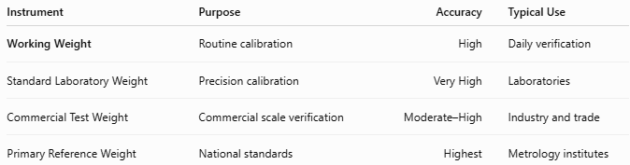
Instrument | Purpose | Accuracy | Typical Use
Working Weight | Routine calibration | High | Daily verification
Standard Laboratory Weight | Precision calibration | Very High | Laboratories
Commercial Test Weight | Commercial scale verification | Moderate–High | Industry and trade
Primary Reference Weight | National standards | Highest | Metrology institutes

Care and Maintenance
# Source: AI Source: Provided by: [Data Path: Persons Table -> ID Column: 1, Name_En Column: Motasem Essam] -> From: [ChatGPT] on [7/17/2026]
To preserve accuracy:
- Store in protective cases.
- Keep weights clean and dry.
- Handle with gloves or tweezers (small weights).
- Avoid impacts.
- Recalibrate according to schedule.

Common Mistakes
# Source: AI Source: Provided by: [Data Path: Persons Table -> ID Column: 1, Name_En Column: Motasem Essam] -> From: [ChatGPT] on [7/17/2026]
- Using contaminated weights.
- Touching precision weights with bare hands.
- Storing weights improperly.
- Using weights beyond their calibration interval.

Key Points
# Source: AI Source: Provided by: [Data Path: Persons Table -> ID Column: 1, Name_En Column: Motasem Essam] -> From: [ChatGPT] on [7/17/2026]
- A Working Weight is a reference mass, not a measuring instrument.
- It is intended for routine verification and calibration of weighing equipment.
- Common types:
  - Stainless Steel Working Weights
  - Cast Iron Working Weights
  - Knob Working Weights
  - Weight Sets
- Common OIML classes:
  - F1
  - F2
  - M1
  - M2
- Widely used in laboratories, manufacturing, quality control, and industrial calibration.

Conclusion
# Source: AI Source: Provided by: [Data Path: Persons Table -> ID Column: 1, Name_En Column: Motasem Essam] -> From: [ChatGPT] on [7/17/2026]
A Working Weight is a calibrated reference mass designed for the routine verification and calibration of balances and weighing systems. By providing a reliable and traceable reference, working weights help ensure consistent measurement accuracy in laboratories, industrial facilities, pharmaceutical production, food processing, and quality assurance programs, supporting dependable and repeatable weighing results.

